1. **Find the hottest and coldest day along the station code and date for each year.**

**2010 hottest day**



**2010 coldest day**



**2011 hottest day**



**2011 coldest day**



**2012 hottest day**

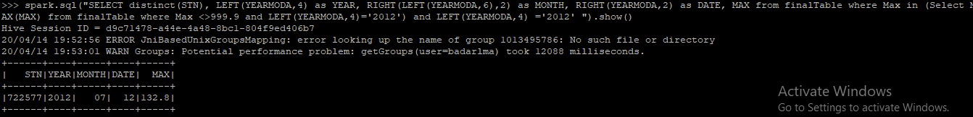

**2012 coldest day**

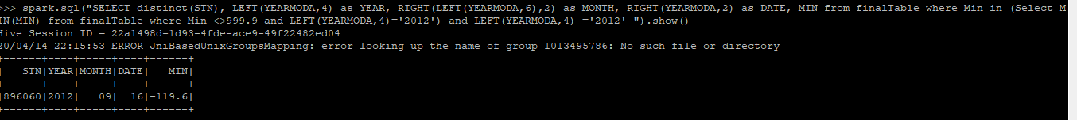

**2013 hottest day**



**2013 coldest day**



**2014 hottest day**



**2014 coldest day**



**2015 hottest day**



**2015 coldest day**



**2016 hottest day**



**2016 coldest day**



**2017 hottest day**



**2017 coldest day**



**2018 hottest day**



**2018 coldest day**



**2019 hottest day**



**2019 coldest day**



1. Find the hottest and coldest day across all years (2010 - 2019) along with station code and date.

Hottest day of all the years

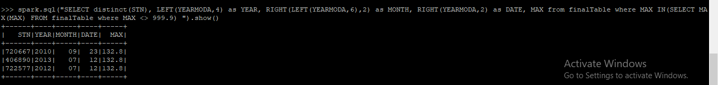

Coldest day of all the years



1. Maximum and minimum precipitation with station code and date for year 2015.

Maximum precipitation for 2015

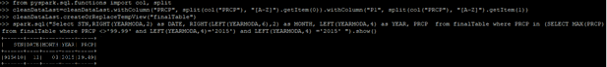

Minimum precipitation for 2015

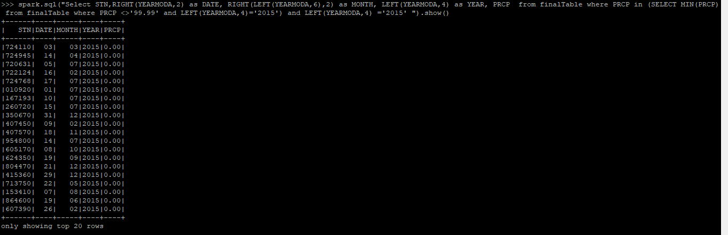

1. Count percentage missing values for mean station pressure (STP) for year 2019 and stations.



1. Station code with maximum wind gust and date for year 2019

